City of Brewster
Shoreline Management Act
Periodic Review and Update Project 2022-2023

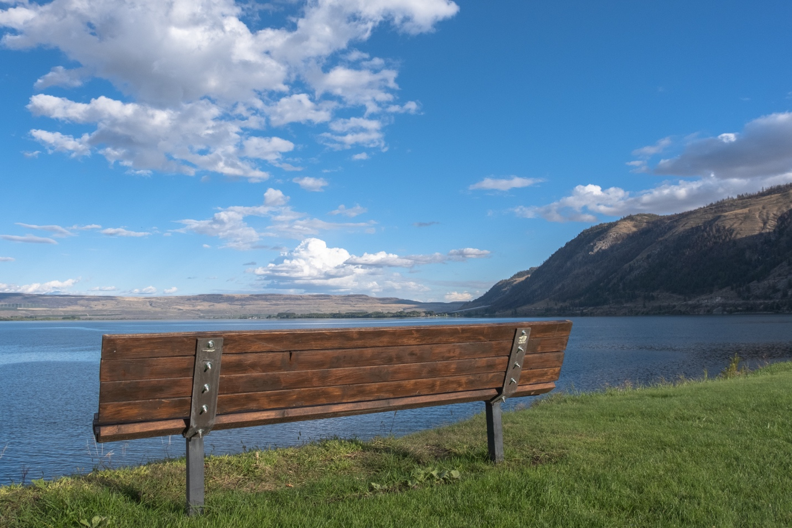
Photo by Michelle Miller

Project Updates

- Please take the survey: https://www.surveymonkey.com/r/BrewsterSMP

- Please review the SMP PowerPoint presentation

Overview
The City of Brewster is proposing a periodic review and update to the City’s Shoreline Master Program (SMP). Previously, the City adopted the Okanogan SMP and then comprehensively updated the SMP in 2012, which was approved by the Department of Ecology. The SMP is a combined planning and regulatory document that contains the City’s policies, goals, and specific land-use regulations for shorelines and consistent with the Shoreline Management Act (SMA) is intended to balance development, public access, and protection of natural resources and shoreline areas.

What is the Shoreline Management Act (SMA)?
The shorelines of the state are among the most valuable and fragile of Washington’s natural resources. The SMA was enacted to protect the shorelines uses and development. The SMA is a cooperative program between the local government (City of Brewster) and the State (Department of Ecology). Ecology acts primarily in a supportive and reviewing capacity and must approve SMPs.

What is the Shoreline Management Program (SMP)?
The SMP is a collection of regulations pertaining to shoreline protection, use, and development.

What is a Periodic Review?
The Periodic review is meant to look at what has changed in the community and in the rules and bring our SMP up to date. It is required every eight years, under RCW 90.58.080(4) to make sure the City stays current and complies with the requirements of the SMA.

Where Does the SMA apply?
The SMA applies to:

- All marine waters [none in Brewster]
- Streams and rivers with greater than 20 cubic feet per second mean annual flow
- Lakes 20 acres or larger
- Upland areas called shorelands extending 200 feet landward from the edge of the water
- Wetlands and deltas connected to bodies of water
- 100 year floodplains
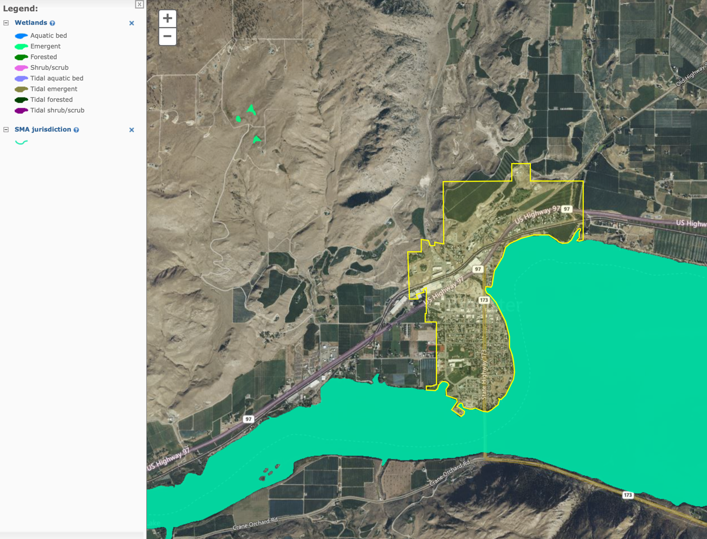

How Can You Participate?
The goal is to provide the public with timely information, an understanding of the process, and multiple opportunities to review and provide comments before final decisions are made. To participate, you can do any or all of the following:
- Sign up for email updates and meeting notices; if you would prefer mail, please provide mailing address.
- Read the documents
- Attend public meetings
- Share your ideas and comment during the public comment periods
- Give testimony at public hearings
- Fill out the survey
- Attend the community meeting and provide comments

The City intends on scheduling at least three opportunities for the public to engage and provide comments.

Project Steps and Milestones – March 2022 – December 2022

City’s Public Participation Schedule
Summer 2022 | Determine Scope
Summer 2022 | Develop Public Participation Plan; Circulate to Community and Stakeholders; Submit to Ecology for Approval | Comments
August 16, 2022 | Launch Website | Comments
August 16, 2022 | Survey | Comments
 | Community Workshop | Comments
Winter 2023 | Review Amendments and Updates | Comments
Winter 2023 | Public Hearing on Draft Proposal | Comments
Winter 2023 | City Council Review and Public Hearing | Comments
Spring 2023 | Submit to Ecology for Approval
Summer 2023 | Adoption of Resolution

Links to Shoreline Materials

The documents and links below consist of task performed and materials produced as part of the SMP update. Ecology provides grants to communities updating the SMP. Some of the documents are required deliverables as part of the grant agreement with Ecology. Project documents will be uploaded and linked here as they are prepared:

- FAQ
- Shoreline Master Program
- Public Participation Plan
- Survey
- PowerPoint

Contact Us
The primary contacts for the City of Brewster SMP update are:
Misty Ruiz, City Clerk
509-689-3464, misty.ruiz@brewsterwa.us
Kurt Danison, Contract Planner
509-322-4037, kdanison@ncidata.com

